Final Project Design Phase
Computer Science - Week 11
Oct 3, 2026 - Version 0.0.4

For complete instructions and project ideas, refer to the assignment in Canvas. Specifically, review the final project requirements before you continue below. If you have not reviewed the project requirements in Canvas (you might have to go to the modules view and check the current or past week's content), you will not be able to properly complete the parts below. In addition, it may be helpful to review the information on this Drafter documentation page.

0) Project Planning and Preparation
Successful programmers spend time planning before they begin coding. After reviewing the project requirements, answer the following questions to help guide your design and development process.
- What concepts from class or previous assignments might help you complete this project? Which programming concepts (loops, conditionals, lists, classes, etc.) do you expect to use? What programming skills do you want to improve while completing this project?
Concepts like dataclasses, lists, conditional statements, and for loops from earlier chapters can be used to help me complete this project. I want to improve my ability to use loops and dataclasses.

- Which parts of the project do you expect to be the easiest for you? The hardest? Why?
I expect making the input functions and creating the dataset to be the easiest part. The hardest part for me will be using dataclasses and loops because I haven't grasped them entirely.

- Even though you have not yet designed the final project, estimate which tasks will likely require the most time and effort? Which features or components should be implemented first?
Setting up the State things and the code for ranking will take the most time and effort. The main dataclasses like Game and the options for the basic inputs should be implemented first.

- What distractions might interfere with your work and how will you minimize them? What resources will you need available while working? What questions, if any, do you still have about the assignment requirements?
I get distracted very easily if there are any people around me so I should probably find a very quiet place in the library or do the work first thing when I get home.

1) Site Diagram
Create a mock-up of your planned website. We suggest you make the mockup on paper, although you can also use software like PowerPoint or Slides to make a mockup. There is other design software that could also be used, but we strongly encourage you to keep it simple. Do not spend more than 15-30 minutes detailing the mock-up. Your goal should be to make a very quick and dirty diagram, to show that you have some kind of idea.

We recommend drawing each page as a rectangle, and laying out the text, buttons, and other components inside. Then, use arrows to indicate links between pages. Label each page the way you will name each function, and then put labels on the arrows to indicate what the button links. Also write down any parameters that should come into the pages.

In addition to the pages and routes, write down what fields your `State` will have, both their names and types. Think clearly about what data will need to be persistent across the entire website.

Add photo(s) or screenshot(s) of your website mock-up and labeled diagram on the next page.
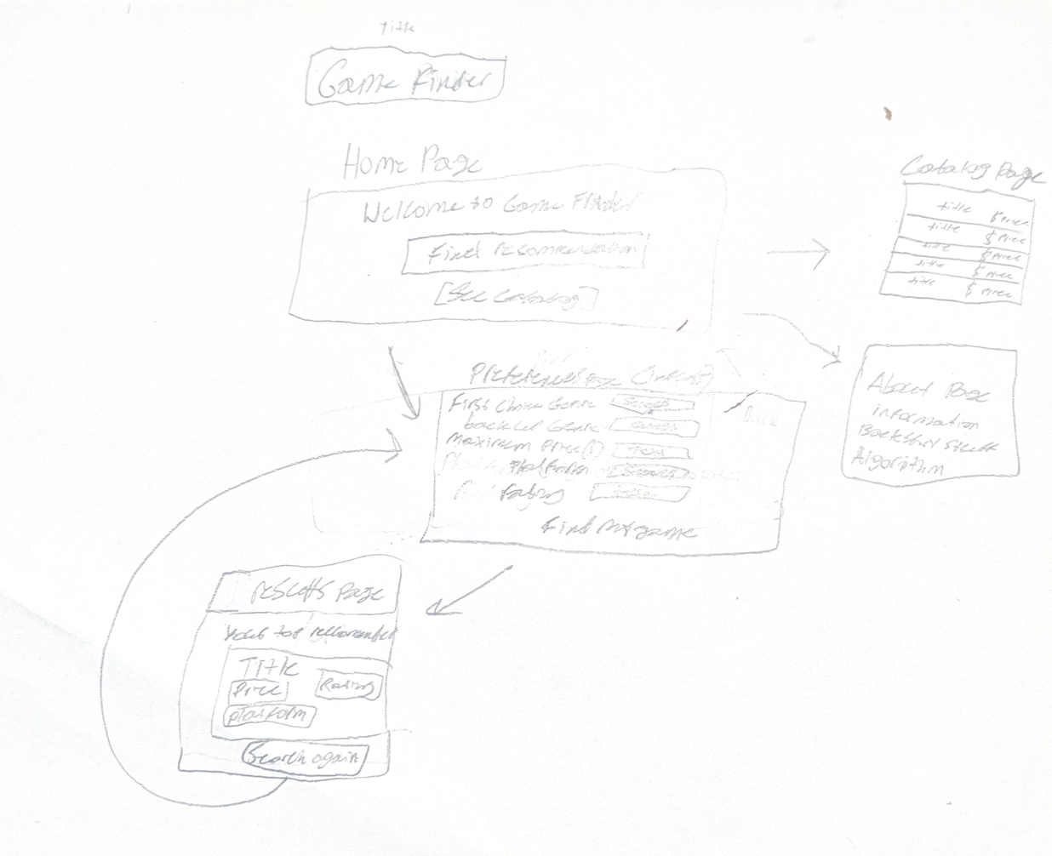

2) Implementing Requirements
This table should serve as a draft for how you will implement the requirements into your final project. You may change your ideas later on, but your final site must fulfill all the requirements.

Requirement | Implementation
Purpose/Functionality  Allows players to input their specific preferences for a game to quickly get a game tailored to their preferences of price, genre, and rating. | A web page that will help users find video game recommendations based on their preferred game genre, maximum price, platform, and rating. It will also have fallbacks in case no games match the first choice.
State Dataclass Attributes  Tracks the users inputs across routes and contains the dataset of the video game items that later get filtered and changed as the user goes through. | all_games(list of Game instances)  user_genre(str)  backup_genre(str)  max_price(float)  min_rating(float)  selected_platform(str)
Second Dataclass  Represents individual video games with properties that are halfway determined by the user (price, genre, rating, and platform) while the title is given as the result of the search through the data. | Class name: Game  Class Attributes:  title(str)  platform(str)  genre(str)  price(float)  rating(float)
Routes (minimum 7)  Allows the player to go in between pages, processes user inputs, and evaluate the objects in the game against the preferences that the user gives. | @route(“/”) (Home)  @route(“/preferences”)  (input)  @route(“/results”)  (output recommendation)  @route(“/fallback”)  (Option for backup genre)  @route(“/catalog”)  (To browse all games)  @route(“/about”)  (Information page)  @route(“/confirmation”)  (submission)
Pages (minimum 5)  Gives a structured webpage to users so they can go through the recommendation workflow. | Home Page  Preferences page  Catalog page  Results page  About page
User Input (minimum 3)  Collects the parameters from the user to drive the filtering algorithms.  For more information on these input types, see Drafter Documentation. | SelectBox: Choose genre  (Is a selection box because users might try to type in in differently leading to the program not working)  TextBox:Enter maximum price  SelectBox:Choose system/platform  TextBox:Enter minimum rating  (0<rating<=5)
If Statements (minimum 3)  Directs the flow of the program, triggers the fallback options and filters out invalid budget options. | Check if first choice genre search returns any matching games  Check if user price input is a valid number  Check if the game rating is higher than the users minimum
Loop (minimum 1)  Allows the program to go through the entire dataset in order to find the recommendation of the highest value. | A for loop that goes over the entire dataset by iterating over the all_games list inside of the State attribute to check each game’s price, rating, and genre against the users preferences.

LLM Conversation
If you used an LLM in any part of this work, copy and paste every part of that conversation below. Otherwise, you may be given a zero for the assignment. Obviously, these words will not all be yours, and this is the exception to the requirement at the top of this assignment that all responses be in your own words. If you did not use an LLM to assist you in this assignment, simply say so below.
Me:
Can you explain how i am supposed to use a state dataclass when making a program. can you also explain how to decide what to write inside of a route
AI: Absolutely! These two concepts are probably some of the most important things to understand when building programs with Drafter. Once you understand how a State dataclass and routes work together, designing an interactive program becomes much easier.
I'll explain them using the structure and examples from your Python Bakery textbook.

1. Understanding the State dataclass
First, think about what your program needs to remember.
Imagine you're making a bakery ordering website. A customer should be able to:
- Enter their name.
- Choose how many cupcakes they want.
- Choose a cupcake flavor.
- See their order.
Your program needs somewhere to store all this information as the customer interacts with the website.
That's what the State dataclass is for!
Think of State as your program's memory.

What goes inside State?
The general rule is:
Put information inside State if your program needs to remember it as the user moves between routes.
For example, consider these fields:
@dataclass
class State:
customer_name: str
cupcake_amount: int
flavor: str
Notice that we have three attributes:
- customer_name stores the customer's name.
- cupcake_amount stores how many cupcakes they want.
- flavor stores their chosen flavor.
Each attribute represents one piece of information that the program needs to remember.

How do you decide what attributes to include?
I recommend asking yourself three questions:
- What information does my program need to keep track of?
- What information might change while the user interacts with the program?
- What information will I need again on a different page or route?
If the program needs to remember something between interactions, it's a good candidate for State.
For example, in a guessing game, you might need:
- The secret word.
- The letters the player has guessed.
- The number of incorrect guesses.
- The player's score.
Your textbook demonstrates this exact idea in its word guessing game. It uses a State dataclass to keep track of the secret word, guesses, wrong guesses, level, and score.
bakery_complete.md

How does State get its initial values?
At the bottom of a Drafter program, you have:
start_server(State(...))
This creates the initial State instance.
For example, if your State has three attributes, you need to provide three initial values in the correct order.
The important distinction:
- The dataclass defines WHAT information you want to remember.
- start_server creates the initial values for that information.

2. Understanding routes
Now that you understand State, let's talk about routes.
A route is essentially a function that determines what happens when a user visits a page or interacts with something on a page.
Think about a website.
You might have:
- A home page.
- An ordering page.
- A confirmation page.
Each of these could have its own route.
In Drafter, routes are written using @route.
For example:
@route
def index(state: State) -> Page:
return Page(state, "Welcome!")
Let's break this down.
Code | Meaning
@route | Registers this function as a route.
def index | Defines the route's name.
state: State | Receives the current State instance.
-> Page | Indicates the function returns a Page.
return Page(...) | Determines the state and content of the page.
An important thing to understand is that every route receives the current State as its first parameter.
This means that you can access your stored information using dot notation.
For example:
state.customer_name
state.cupcake_amount
state.flavor
These expressions access the attributes inside your State instance.

3. How do you decide what to write INSIDE a route?
This is probably the most important part of your question.
Instead of thinking about routes as places where you randomly write code, think about them as having a specific responsibility.
For every route, ask yourself:
What is supposed to happen when the user gets here?
There are three main things to consider.

A. What should the user see?
This is where you create the page content.
For example:
content = Div(
"Welcome to the bakery!",
Button("Start Order", "order")
)
You are deciding what information and interactive components appear on the page.

B. Does the user provide any information?
If the user needs to enter something, you might use:
- TextBox
- Other Drafter input components
For example, a TextBox can collect the customer's name.
The name you give the TextBox is important because it corresponds to a parameter in the route that receives the input.

C. Does anything need to change in State?
This is where you decide whether the route needs to update the program's memory.
For example, imagine a customer submits an order.
The route might receive their chosen flavor and update the State to remember it.
Your textbook explains that route parameters capture temporary information from the user's interaction, while State stores information that needs to persist between routes.
bakery_complete.md

4. Understanding how State and routes work together
Let's walk through a small example conceptually.
Imagine a cupcake ordering website.

Page 1: Home page
Route: index

Welcome to the Bakery!
Ready to order some cupcakes?
Start Order

Page 2: Ordering page
Route: order
Enter your name
Your name...
Choose a flavor
Chocolate
Submit Order

Page 3: Confirmation page
Route: confirmation

Order confirmed!
Customer: Alex
Flavor: Chocolate
Notice how each route has a different responsibility.
Route | Responsibility
index | Displays the welcome page.
order | Displays the order form.
confirmation | Displays the submitted order.
The State allows the confirmation page to access information that the customer entered on the previous page.
Here's the important distinction:
- Routes determine what happens.
- State remembers information.
- Route parameters receive information from the user's interaction.
- Page returns the updated State and the page content.

5. A strategy for writing routes yourself
Whenever you start writing a route, try following this thought process.
- Identify the purpose.
- What is this route supposed to accomplish?
- Identify the information needed.
- What State attributes or user inputs does this route need?
- Determine whether State changes.
- Does the user interaction require you to remember new information?
- Determine what the user should see.
- What components should appear on this page?
- Return a Page.
- Does your returned Page contain the correct State and content?
One additional thing: Not every route needs to update State!
For example, your index route might simply display the current information. Another route might update a score, collect a guess, or change the customer's order.
Your textbook specifically recommends that the index route generally displays information, while other routes handle interactions and state updates.
I dont know why the backgrounds are different colors i didnt highlight anything

Final Submission
When you are finished, download this file as a Word Document (docx) and upload the file to the appropriate assignment on Canvas.

